Using Generative AI Models to Support Cybersecurity Analysts

Abstract
One of the tasks of security analysts is to detect security vulnerabilities and ongoing attacks. There is already a large number of software tools that can help to collect security-relevant data, such as event logs, security settings, application manifests, and even the (decompiled) source code of potentially malicious applications. The analyst must study these data, evaluate them, and properly identify and classify suspicious activities and applications. Fast advances in the area of Artificial Intelligence have produced large language models that can perform a variety of tasks, including generating text summaries and reports. In this article, we study the potential black-box use of LLM chatbots as a support tool for security analysts. We provide two case studies: the first is concerned with the identification of vulnerabilities in Android applications, and the second one is concerned with the analysis of security logs. We show how LLM chatbots can help security analysts in their work, but point out specific limitations and security concerns related to this approach.
Keywords: LLM; Cybersecurity; vulnerability assessment

🔍 What the paper is about:
The paper explores how Large Language Models (LLMs) — like ChatGPT — can assist Cybersecurity analysts in identifying vulnerabilities and attacks.

🛠️ Current Situation:
Security analysts already use many tools that collect data such as:
- Event logs
- Security settings
- Application details (e.g., source code of apps)
However, analysts still need to manually analyze, evaluate, and classify this information to detect threats.

🤖 New Idea:
With the rise of AI and LLMs, tools like chatbots can now:
- Summarize data
- Generate reports
- Provide insights from raw security data
This paper investigates whether these LLMs can be used as “black-box” assistants — meaning, the analyst gives input and gets results without needing to know how the model works internally.

📊 Case Studies in the Paper:
- Android App Vulnerability Detection
  - Uses LLMs to help find flaws in mobile apps.
- Security Log Analysis
  - Uses LLMs to assist in making sense of event logs.

⚠️ Findings and Concerns:
- Pros: LLMs can help analysts work faster and more effectively.
- Cons: There are limitations (e.g., model hallucination, lack of explainability) and security risks (e.g., leaking sensitive data, incorrect assessments).

🧩 Keywords Explained:
- LLM: Large Language Models like ChatGPT
- Cybersecurity: Protecting systems from digital attacks
- Vulnerability Assessment: Identifying weaknesses in software/systems

Visual summary :

🛡️ Using Generative AI to Help Cybersecurity Analysts

🔍 Problem
Cybersecurity analysts deal with huge amounts of data
(e.g., event logs, app code, settings)
➤ Manual analysis is time-consuming and complex

🤖 Solution Explored
Use Large Language Models (LLMs) like ChatGPT as assistants to:
- Summarize security data
- Help detect vulnerabilities
- Interpret logs

🧪 Case Studies
Case Study | Description
📱 Android Vulnerability Detection | LLMs analyze Android apps for potential flaws
📋 Security Log Analysis | LLMs interpret logs to find suspicious behavior

✅ Benefits
- Faster analysis
- Better summaries
- Reduces manual workload

⚠️ Challenges
- ❗ LLMs may hallucinate or give wrong answers
- 🔒 Risk of leaking sensitive data
- 🧠 Lack of explainability (black-box behavior)

💡 Conclusion
LLMs can be valuable tools, but must be used with caution due to risks.

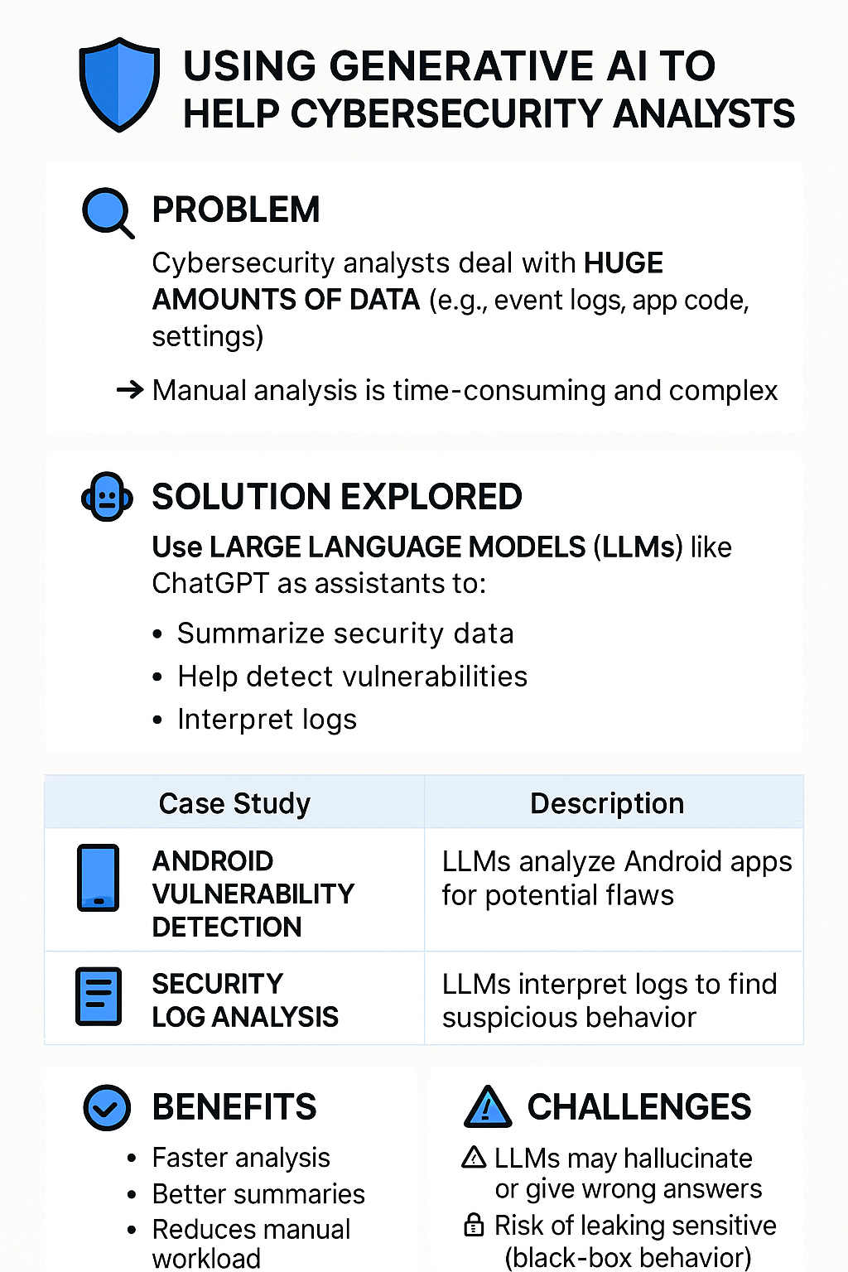

🧠 How LLMs Are Used in Cybersecurity Tasks

🔧 1. Data Summarization
- LLMs can digest long logs or reports and provide concise summaries.
- Useful for daily Security Operation Center (SOC) briefings.
- Reduces human fatigue from reading repetitive entries.

🔎 2. Threat Classification
- Analysts can input unusual log entries or code snippets.
- The LLM suggests likely threat categories (e.g., malware, phishing, misconfig.)
- Speeds up triage decisions.

📂 3. Reverse Engineering Aid
- De-compiling apps produces hard-to-read source code.
- LLMs can help explain the purpose of suspicious code blocks.
- Especially helpful for Android APK analysis in malware research.

🛠️ 4. Incident Report Drafting
- After an incident, LLMs assist in writing reports:
  - What happened?
  - What was affected?
  - What actions were taken?
- Ensures quicker documentation.

🚨 Limitations & Mitigation Strategies
Limitation | Description | Suggested Mitigation
❌ Hallucination | LLMs may invent incorrect facts | Use verification steps with known databases/tools
🔐 Data Leakage | Inputting raw data may expose secrets | Run LLMs locally or on secured air-gapped systems
📦 Black-box behavior | Models don’t explain why they respond a certain way | Use LLMs as support, not final authority

🧪 Future Scope & Research Areas
- Fine-tuning LLMs on Cybersecurity datasets
  - Improves reliability and accuracy.
- LLMs integrated with SIEM tools
  - E.g., Splunk + GPT for interactive queries.
- Chain-of-Thought prompting
  - Asking LLMs to "think step-by-step" before answering.

📘 Real-World Use Cases
- Google's Chronicle Security: Integrates AI to help search and contextualize threat data.
- Microsoft Security Copilot: Uses GPT-4 for assisting enterprise defenders.
- Cybersecurity startups: Developing custom AI co-pilots for security teams.

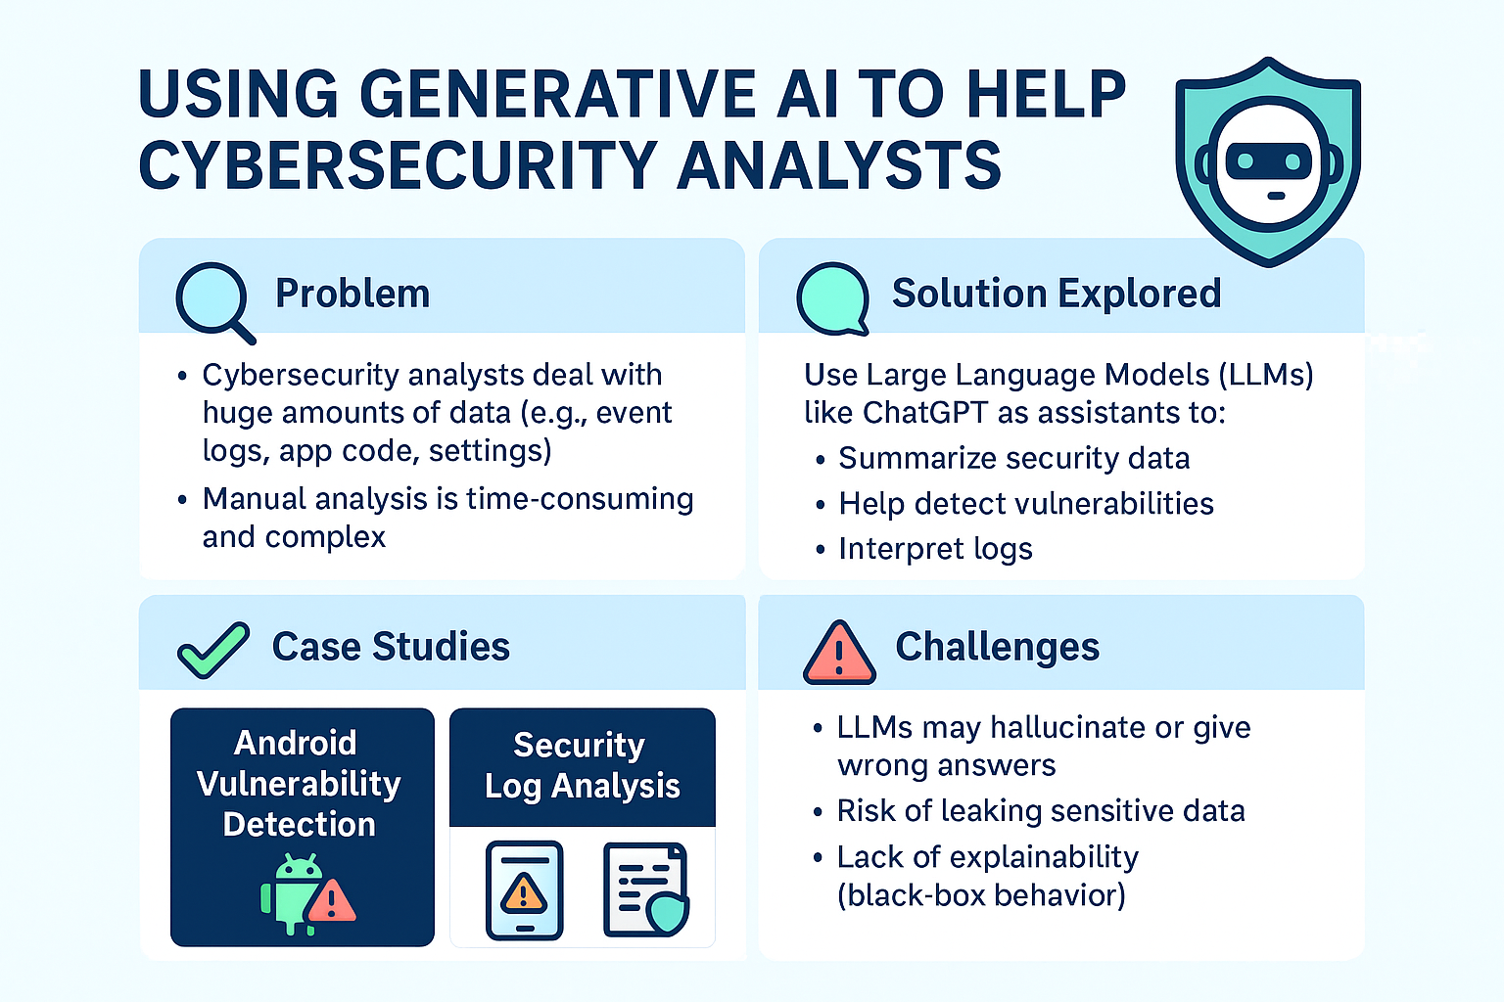
Explanation of the info-graphic : "Using Generative AI to Help Cybersecurity Analysts"

🧩 1. Title and Theme
The title at the top clearly sets the context:
It’s about using Large Language Models (LLMs), like ChatGPT, to assist Cybersecurity analysts.

🔍 2. Problem Section (Top Left Box)
Icon: 🔍
Key Points:
- Cybersecurity analysts must handle large volumes of data: logs, code, settings, etc.
- Manual analysis is not only slow, but also complex and mentally exhausting.
👉 This highlights the need for automation or intelligent assistance.

🤖 3. Solution Explored (Top Right Box)
Icon: 🤖
Key Points:
- LLMs (like ChatGPT) can act as AI assistants.
- They can:
  - Summarize complex security data
  - Detect vulnerabilities
  - Interpret system logs
👉 This shows how AI can reduce analyst workload while improving insights.

📚 4. Case Studies (Bottom Left Box)
Icon: ✔️
Two real-world examples of AI helping analysts:
- Android Vulnerability Detection: LLMs analyze Android apps for flaws.
- Security Log Analysis: LLMs review logs to detect suspicious behavior.
👉 Demonstrates practical applications of LLMs in Cybersecurity.

⚠️ 5. Challenges (Bottom Right Box)
Icon: ⚠️
Risks of relying on LLMs:
- They may hallucinate or give inaccurate results.
- Risk of leaking sensitive data if prompts are not handled securely.
- They behave like a black box — it’s hard to understand how they reached a conclusion.
👉 Warns users to use LLMs carefully, not blindly trust them.

🎯 Final Message of the Slide:
LLMs are powerful tools that can help in Cybersecurity analysis, but they must be used responsibly due to certain risks and limitations.

Reference :
- Webasha
- undercodetesting
- ebotify

